## **Part 1: Understand the problem**

## Technical Requirements

### Qualitative

* The device should have a display to provide visual feedback to the user.
* The device should actively track the location of 1 or 2 fingers on the interactive display.
* Disengaging from the device should feel like removing one’s fingers from a ‘sticky’ surface.
* The device should be aware when the user places and removes their fingers from the interactive display.
* The two contact points of the device are limited by the edges of the display. Consideration could be given to rotation limits
* The user should feel no forces when they are not in contact with the interactive display.

### Quantitative

* The device shall have a traversable area of at least 7” by 10”.
* The two contact points shall be able to go as close as ⅜” together or 5” apart
* The two contact points should be able to handle 2 full rotations from a neutral starting point.
* In free motion, the user should experience no more than 0.22 lbs or 100 g of inertia.
* In free motion, the gantry device should be able to match finger speeds up to 150 mm/s or 5.9 in/s.
* When the user is interacting with a virtual wall, the device will be able to respond with a stiffness of 1 N/mm or 5.71 lbs/in
* For sensing and actuation the device will have a resolution of 5 microns.
* The device will have sensing capability that can track the X/Y positions of the two fingers and the two magnets
* The device will be able to provide a maximum of 3 lbs of force
* The device will be able to engage and disengage the magnetic attraction between the gantry and the fingers

## 

## **Part 2: Brainstorm**

### **IDEA 1: Belt Gantry System**

Drawings:

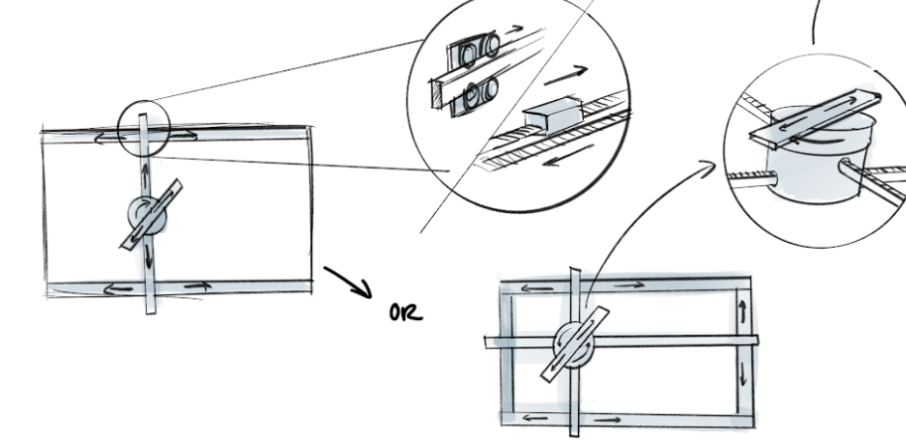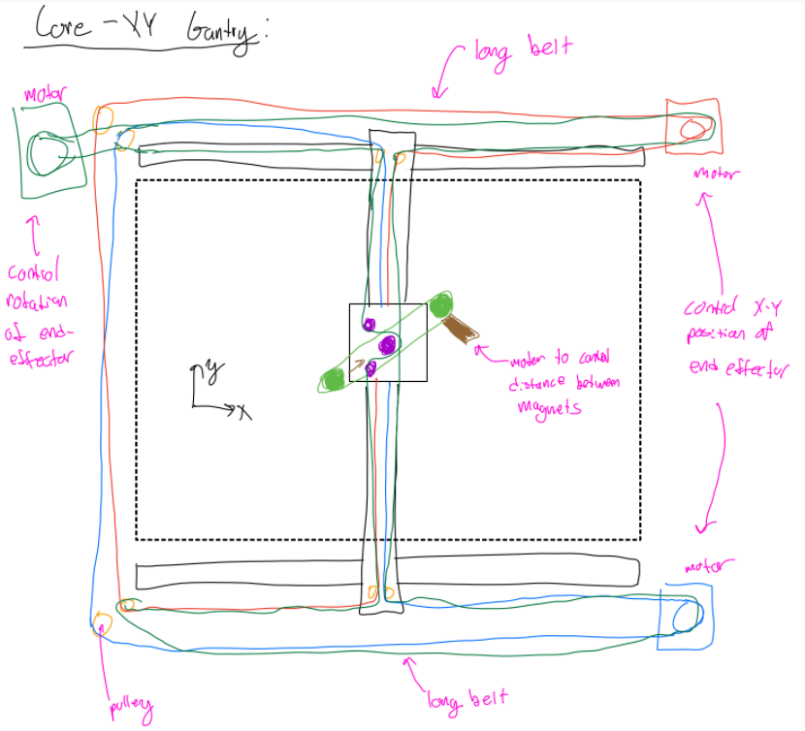

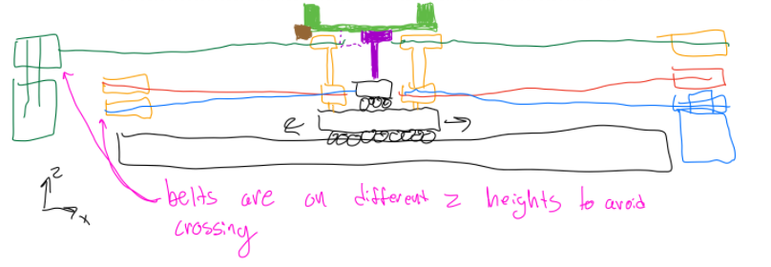

Description:

Use of a Gantry system for our 4DOF robot. In this scenario we would be using a belting mechanism as it is very back-driveable, good for impedance control and we can replace motors with cable drives ideally for the smoothest haptic experience.

Some cons are that the belt system could become mechanically complex (i.e. lots of pulleys, belt heights, etc.) and it requires some space outside of the display and it doesn’t package as nicely. It also still requires an actuator for the final DOF which adds inertia.

### 

### **IDEA 2: Open Chain Linkage**

Drawings:

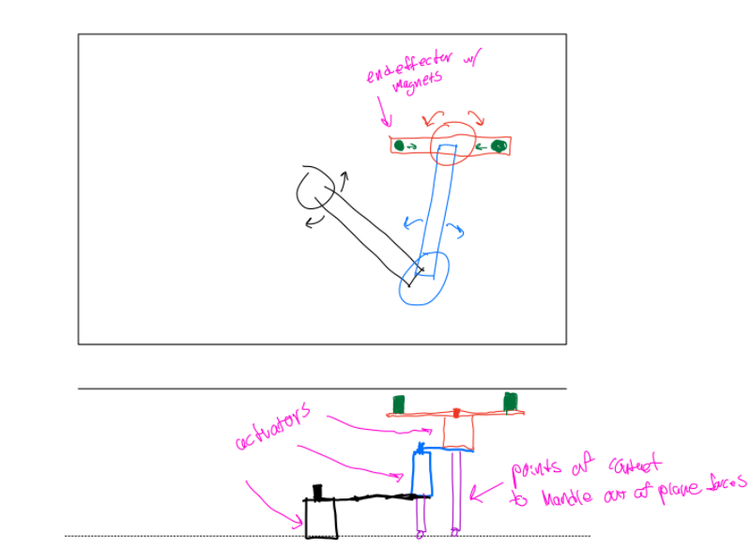

Description:

This design includes a chain link fixed at the center and with different levels that should allow it to reach all parts of the screen with a minimum number of actuators. We could possibly use belts to displace some of the motors to actuate the joints ‘remotely’ (e.g. make the actuators stationary), or use cable drives (best for haptics) in place of the actuators to eliminate backlash and create the best user/haptic experience.

### 

### 

### **IDEA 3: Cable System**

Drawings:

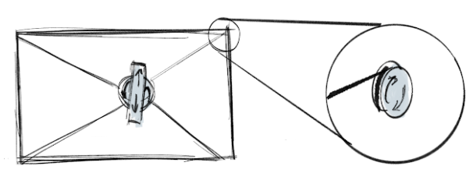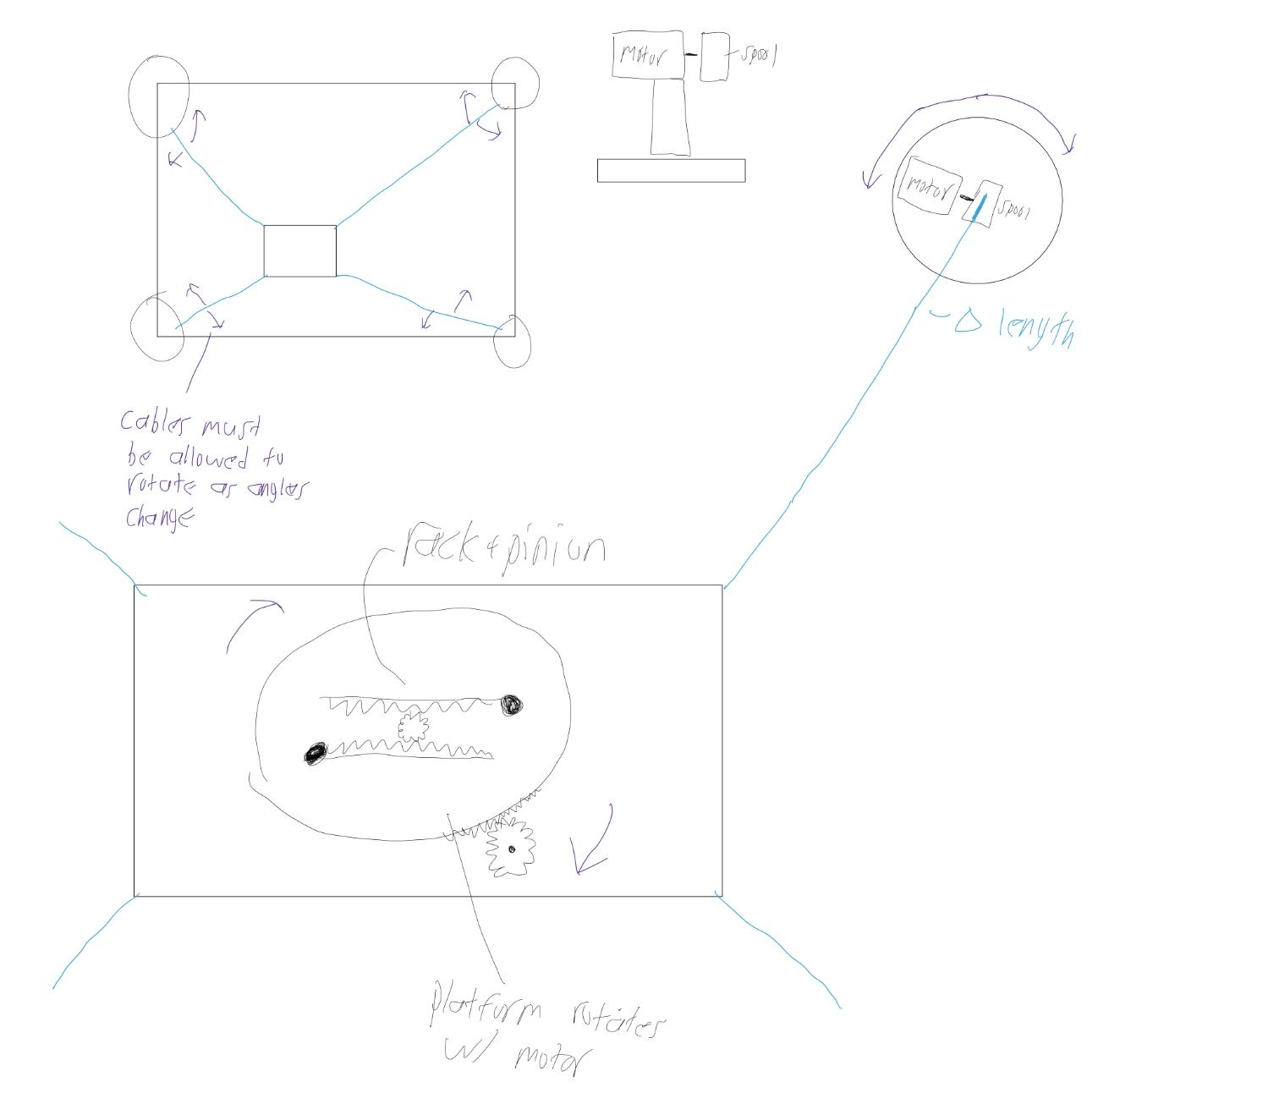

Description:

In this design we got inspired by cable bots and the ability to have the x-y position achieved by the extension and contraction of cables that are in tension. This design benefits from having the motors on the 4 corners of the base, which enables for less wait at the middle mechanism and allows for improved speed.

### **IDEA 4: Robotic Arm**

Drawings:

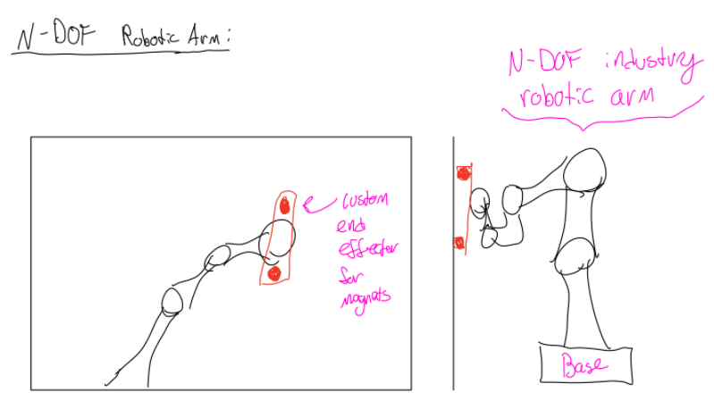

Description:

Industry standard robotic arms are very good at what they do, they have sub-millimeter accuracy, wide ranges of motions, and the control algorithms/loops are already engineered for us. This could save us a lot of engineering work, would likely handle the inertia of the end-effector well and could possibly provide extra degrees of freedom into/out of the display to control magnitude of magnetic forces with finer tuning. However they are rather expensive, a new one likely exceeds budget on its own, they are also large and bulky, which might not package well with a smaller display and they do still requires custom engineering for the end-effector; not an all-in-one solution

### **IDEA 5: Ball Screw Gantry System**

Drawings:

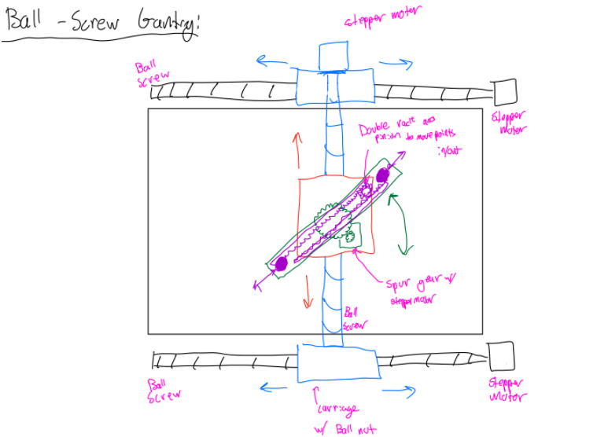

Description:

This design uses a gantry system, like the one on idea 1, as the foundation for the 4DOF system - however, in this scenario, we considered a ball-screw mechanism.

Ball screws are relatively easy to use, have good mechanical advantages with low inertias, and

have little backlash (making them ‘feel’ good for haptics) and don’t need to machine a lot of custom parts, ball screws and ball nuts are very common parts on McMaster-Carr.

## **Part 3: Define abstract system architecture**



Fig 1: Basic System Architecture for Tablet

This diagram shows the general architecture for the Tablet.



Fig 2: Refined system architecture for mobile manipulator



Fig 3: Architecture diagram with sub-team focus areas identified

**SUBTEAMS**

Actuator team: Ray, Lio, Cam

Mechanism team: Sam, Diogo, Jose